FOURTH MEETING OF SIGNATORIES TO THE MEMORANDUM OF UNDERSTANDING ON THE CONSERVATION OF MIGRATORY BIRDS OF PREY IN AFRICA AND EURASIA
(Victoria Falls, 30 November- 2 December 2026)
UNEP/CMS/RAPTORS/MOS4/Doc.14.1

PROPOSED AMENDMENTS TO ANNEX 1 (“SPECIES LIST”) AND TABLE 1 OF ANNEX 3 (“ACTION PLAN”) OF THE RAPTORS MOU
(Prepared by the Coordinating Unit of the Raptors MOU)

Summary:

In accordance with Rule 16 of the Rules of Procedure, the Technical Advisory Group (TAG) proposes amendments to Annex 1 (“Species List”) of the Raptors MOU and to Table 1 of Annex 3 (“Action Plan”), arising from its species-related work under the TAG Workplan 2023-2026.

The proposed amendments reflect updated taxonomy and nomenclature, the addition of bateleur (Terathopius ecaudatus) and Bonelli’s eagle (Aquila fasciata) to Annex 1 on the basis of their migratory status, and consequential amendments to Table 1, including revised wording of the footnote concerning the identification of species for inclusion in Category 2.

The Meeting is invited to adopt the proposed amendments contained in Addenda A and B to this document; endorse the approach proposed by the TAG for identifying species for inclusion in Category 2; consider supporting a proposal to include bateleur in CMS Appendix I; and take note of the species identified for future assessment against the CMS definition of “migratory species”.

Background

- Paragraph 22 of the Raptors MOU provides that the Memorandum of Understanding may be amended at any Meeting of the Signatories, and that any amendment adopted will become effective on the date of its adoption by the Meeting by consensus. Rule 16 of the Rules of Procedure for Meetings of Signatories (UNEP/CMS/RAPTORS/MOS4/Doc.3) provides that proposals for amendment of the MOU, including its Annexes, may be made by one or more Signatories or by the Technical Advisory Group (TAG), and that proposals by the TAG shall be provided to the Coordinating Unit at least 90 days before the Meeting of Signatories at which they are to be considered.

- Paragraph 3.2 of Annex 3 (“Action Plan”) to the MOU provides that the species in Annex 1 are assigned to the categories provided for in paragraph 3.1 as given in Table 1, unless Table 1 is amended in accordance with the agreed procedure.

- The TAG Workplan 2023-2026, contained in Annex 1 to document UNEP/CMS/Raptors/MOS3/Doc.15.3 and noted by the Third Meeting of Signatories (MOS3, Dubai, July 2023), includes the following species-related actions, which are addressed in the present document:

  - Action 1: Ensure changes in taxonomy and/or conservation status and knowledge of movement of migratory raptors are reflected in the Raptors MOU lists, with amendments to Annexes 1, 2 and 3 (Table 1 and Table 3) proposed to MOS;
  - Action 2: Review proposals submitted to MOS for the inclusion of species in Annex 1 of the MOU and provide written comments on each proposal tabled by Signatories;
  - Action 8: Monitor consistency between the IUCN Red List status, Table 1 Category and CMS Appendix listing of species; and
  - Action 9: Clarify the criteria for inclusion of a species in Category 2 of Table 1 of the MOU’s Action Plan.

- The present document, which was reviewed and endorsed by the TAG at its Eleventh Meeting (TAG11), summarises the amendments to Annex 1 proposed by the TAG. It also explains how the species listed in Annex 1 are assigned to Categories 1, 2 and 3 in Table 1 of Annex 3 of the Raptors MOU; compares Annex 1 of the Raptors MOU with the CMS Appendices; and presents the approach proposed by the TAG for identifying species for inclusion in Category 2 of Table 1. The proposed amended Annex 1 is contained in Addendum A to this document; the proposed amended Table 1 of Annex 3 is contained in Addendum B; and the evidence concerning the migratory behaviour of candidate Annex 1 species is summarised in Annex C.

Proposed amendments to Annex 1 (“Species List”)

- Amendments to Annex 1 of the Raptors MOU may be proposed on two principal grounds: (1) revisions to taxonomy and nomenclature to reflect current scientific understanding; and (2) improved knowledge of species’ movement patterns indicating that they meet the CMS definition of a “migratory species”, as applied under the Raptors MOU.

Proposed amendments to Annex 1 on the basis of taxonomy and nomenclature

- In relation to Action 1 of the TAG Work Plan, the Raptors MOU follows CMS with respect to the taxonomic reference used for birds. As set out in CMS Resolution 12.27 (Rev.COP15) on Taxonomy and Nomenclature, the reference for non-passerine birds is del Hoyo, J. and Collar, N.J. (2014), together with updates incorporated into the latest online version. In preparing the amendments proposed for MOS4, the most recent taxonomy and nomenclature available in the 2025 IUCN Red List dataset have been used, as available on the BirdLife DataZone. BirdLife International is working with other key taxonomic authorities towards a harmonised taxonomy and nomenclature for birds, so as part of this work further taxonomic and nomenclatural amendments may be necessary during the next triennium.

- The following changes have occurred since MOS3 and are reflected, as applicable, in the proposed amendments to Annex 1 contained in Addendum A and to Table 1 of Annex 3, contained in Addendum B.

- Change in common name: the common name of Asio otus has changed from northern long-eared owl to long-eared owl. This change requires corresponding amendments to Annex 1 and of Table 1 of Annex 3.

- Recognition of a New family: scissor-tailed kite (Chelictinia riocourii) has changed family from Accipitridae to Elanidae. Elanidae was previously a subfamily within Accipitridae but is now a family in its own right. This change requires amendment of Annex 1.

Proposed amendments to Annex 1 on the basis of migratory status

- This work relates to both Action 1 and Action 2 of the TAG Workplan 2023-2026. In this context, Signatories are reminded that the MOU applies the definition of “migratory species” contained in Article I, paragraph 1(a) of the Convention, namely “the entire population or any geographically separate part of the population of any species or lower taxon of wild animals, a significant proportion of whose members cyclically and predictably cross one or more national jurisdictional boundaries”.
- Between MOS3 and MOS4, the TAG was requested to assess the migratory behaviour of bateleur (Terathopius ecaudatus) and red-headed falcon (Falco chicquera). Bonelli’s eagle (Aquila fasciata) had previously been proposed for addition to Annex 1 by Israel, following which the TAG requested further information on the movements of wild-hatched individuals. Israel subsequently provided additional information, which was assessed by the TAG. The TAG’s assessment of the three species against the CMS definition of “migratory species”, together with the supporting evidence, is presented in Annex C to this document. On the basis of the available information, the TAG considers that bateleur and Bonelli’s eagle meet the CMS definition and proposes that they be added to Annex 1. The TAG considers that the information currently available for red-headed falcon is insufficient to demonstrate that the species meets the CMS definition and therefore does not propose its addition to Annex 1 at this time. If the Meeting adopts the proposed amendments, Annex 1 will contain 96 species.
Future species to assess for Annex 1 on the basis of migratory status

- Taking into account species previously assessed by the TAG and recent work undertaken by the CMS Scientific Councillor for birds to assess the world’s bird species against the CMS definition of “migratory species”, the following raptor species occurring within the area of the MOU have been identified as candidates for possible assessment or reassessment by the TAG during the next triennium:

Secretary-bird (Sagittarius serpentarius)
Palm-nut vulture (Gypohierax angolensis)
Black sparrowhawk (Astur melanoleucus)
Eurasian eagle-owl (Bubo bubo)
White-eyed buzzard (Butastur teesa)
Western banded snake-eagle (Circaetus cinerascens)
Southern banded snake-eagle (Circaetus fasciolatus)
Grey kestrel (Falco ardosiaceus)
Greater kestrel (Falco rupicoloides)
Eurasian pygmy-owl (Glaucidium passerinum)
Brahminy kite (Haliastur indus)
Lesser fish-eagle (Icthyophaga humilis)
Black eagle (Ictinaetus malaiensis)
Lizard buzzard (Kaupifalco monogrammicus)
Long-crested eagle (Lophaetus occipitalis)
Pale chanting-goshawk (Melierax canorus)
Dark chanting-goshawk (Melierax metabates)
Eastern chanting-goshawk (Melierax poliopterus)
Gabar goshawk (Micronisus gabar)
African scops-owl (Otus senegalensis)
African harrier-hawk (Polyboroides typus)
Crested serpent-eagle (Spilornis cheela)

- The TAG may identify additional species for assessment or reassessment during the next triennium and establish an order of priority for undertaking those assessments.

Proposed amendments to Table 1 of Annex 3 (“Action Plan”)

- In relation to Action 1 of the TAG Workplan, Table 1 of Annex 3 of the Raptors MOU assigns all species listed in Annex 1 to Categories 1, 2 or 3 according to their conservation status. The categorisation follows the criteria set out in section 3 of Annex 3 and is based on the most recent conservation status assessments available. Global IUCN Red List status and global population trend information were obtained from the 2025 IUCN Red List dataset maintained by BirdLife International. An analysis of the changes to Table 1 over time is included in the Second Conservation Status Assessment Report (document UNEP/CMS/RAPTORS/MOS4/Doc.12.4).

- Category 1 includes species classified on the IUCN Red List as globally threatened or Near Threatened. Category 2 comprises species considered to have an Unfavourable Conservation Status at the regional level within the area of the Raptors MOU, in accordance with the footnote to Table 1. Category 3 includes all other species listed in Annex 1. The principal source used to assess regional conservation status in the European part of the MOU area was the latest European Red List of Birds. As discussed below, further guidance is to be developed on the assessment of regional conservation status in other parts of the MOU area where assessments covering an entire region are not available.

- No species listed in Annex 1 has undergone a change in its status based on the global IUCN Red List since MOS3, and the European Red List of Birds is expected to be updated in December 2026. Accordingly, subject to the adoption by MOS4 of the proposed amendments to Annex 1, the TAG proposes the following additions to Table 1:

- Bateleur, which is classified as Endangered on the global IUCN Red List, should be added to Category 1; and
- Bonelli’s eagle, which is classified as Least Concern species on the global IUCN Red List and has a stable global population trend, should be added to Category 3.

- All other species would remain in the categories assigned to them by MOS3. The proposed amended Table 1, incorporating the above changes and the updated common name of Asio otus, is contained in Addendum B to this document. The TAG further proposes that footnote 4 to Table 1, concerning Category 2, be amended as set out in Addendum B.

Comparison of Table 1 with the CMS Appendices

- In relation to Action 8 of the TAG Workplan, CMS Appendix I already includes most of the species in Category 1 that are classified as Critically Endangered and Endangered. The exception to this remains black harrier (Circus maurus), which, although Endangered on the global IUCN Red List since 2017 and in Category 1 of Table 1 of the Raptors MOU, is not included in CMS Appendix I. Even before this global uplisting, TAG3 had identified the species as a potential priority for the development of an international species action plan. The species has a very limited range comprising South Africa, which is a Party to CMS Party, and Namibia and Lesotho, which are not Parties. The scope for international cooperation for the species through CMS is therefore currently limited.

- If MOS4 agrees to add bateleur to Annex 1 of the Raptors MOU, the species would be included in Category 1 of Table 1. As a species classified as globally Endangered, it would also meet the conservation-status basis for consideration for inclusion in CMS Appendix I. Bateleur is currently covered by CMS Appendix II through the family-level listing of Accipitridae. Its addition to Annex 1 and Category 1 of the Raptor MOU would strengthen the basis for the development of a proposal for its inclusion in CMS Appendix I for consideration by the Sixteen Meeting of the Conference to CMS (COP16).

- CMS Appendix II: This Appendix covers species which have an unfavourable conservation status and which require international agreements for their conservation and management, as well as those which have a conservation status which would significantly benefit from the international cooperation that could be achieved by an international agreement. At species level this clearly covers those species which are Vulnerable and Near Threatened on the global IUCN Red List, but the case can also be made exceptionally for inclusion of Least Concern species with declining populations or populations with deteriorating conservation status. CMS Appendix II already covers osprey (Pandion haliaetus) and has family-level listings for Accipitridae, Elanidae and Falconidae. Snowy owl (Bubo scandiacus) was previously identified by the TAG as a species missing from the CMS Appendices and was successfully added to CMS Appendix II at COP15 by CMS Parties upon proposal by Norway with input from the TAG. This was an important advance, being the first owl to be listed on the CMS Appendices. Apart from the issues identified above, no Vulnerable or Near Threatened species currently listed, or proposed for inclusion, in Annex 1 of the Raptors MOU remain outside the relevant CMS Appendix listings.

Criteria for inclusion of a species in Category 2 of Table 1

- Action 9 of the TAG Workplan 2023-2026 requests the TAG to clarify the basis for including species in Category 2 of Table 1 of the MOU’s Action Plan. Under the existing footnote to Table 1, one basis for identifying species with an Unfavourable Conservation Status for inclusion in Category 2 is a declining global population trends. The other bases rely on regional processes for identifying Unfavourable Conservation Status and are currently focused principally on Europe.

- To date, assessments of conservation status and population trends covering an entire region have been available only for Europe. The TAG recognises that the substantial investment and volunteer capacity required to collect information through monitoring and surveys and to undertake assessments at the regional level may not yet be available in other regions, notwithstanding the growing body of expertise and the emergence of citizen-science schemes. The TAG also recognises that the regions differ significantly in geographic extent. An assessment covering Africa, for example, would be a substantially larger undertaking than an assessment covering Europe.

- A its Ninth Meeting (TAG9), the TAG identified the following objectives for the categorisation of species in Table 1:

- species should be categorised in a manner that accurately reflects their conservation status and population trajectory;
- the categorisation should be capable of responding to genuine changes in status and trend as rapidly as possible;
- information collected at an appropriate geographic scale from across the MOU area should contribute to the identification of species with an Unfavourable Conservation Status;
- the information should cover a sufficiently broad geographic area to be representative of the conservation status of the species across the region concerned;
- the categorisation should be sufficiently robust not to respond to minor fluctuations occurring at limited geographic scale; and
- any definition or guidance should be practical for the TAG to apply.

- During TAG9, the TAG considered several tests cases and applied a number of preliminary criteria to them. The TAG emphasised that criteria for assigning species to Category 2 should, as far as possible, avoid perpetuating disparities between regions in their capacity to detect and recognise, under the Raptors MOU, species whose populations are declining or whose conservation status is deteriorating at the regional level. The TAG expressed particular concern that knowledge gaps in some regions could result in such species not being recognised sufficiently early if the requirements for inclusion in Category 2 remained stringent and focused primarily on European assessment processes. In applying the precautionary principle, the TAG considered that the risk of failing to include a species that genuinely had an Unfavourable Conservation Status in a region was considerably greater than the risk of including a species in Category 2 that was subsequently found not to have such a status.

- The TAG considered several possible approaches, including the delineation of subregions and the application of stringent criteria for determining an Unfavourable Conservation Status at the regional level. It concluded, however, that it would not be possible to anticipate all circumstances concerning the availability of data from different parts of a region. Knowledge gaps in several regions would also make it difficult to establish the baselines required to measure decline. The TAG therefore considered that rigid criteria would not be appropriate. It also concluded that defining geographically equivalent subregion would not address the underlying challenges of assessing incomplete information and might not align with other processes under CMS.

- Rather than establishing rigid criteria, the TAG agreed to use its regional expertise to identify species for which there are indications of an Unfavourable Conservation Status at the regional level, but for which no region-wide assessment is available and would otherwise be placed in Category 3 because the IUCN Red List identifies their global population trend as stable or increasing. Once the TAG agreed on a shortlist of species for assessment, available information on their conservation status and population trends will be collated from different parts of the region and supplemented, where appropriate, by expert opinion from areas for which sufficient data are unavailable. The TAG will then assess whether the available information is representative of an Unfavourable Conservation Status across the region as a whole. Where the TAG reaches that conclusion, it shall submit a proposal, supported by an appropriate justification, for the inclusion of the species in Category 2 for consideration by the Meeting of Signatories. where the available information is insufficient to reach a conclusion, the species will be identified as requiring further research and monitoring.

- The TAG agreed to develop concise guidance to support these assessments and promote consistent approach over time and across regions. The guidance would support the application of the precautionary principle, the evidence-based categorisation of species in Category 2 and Category 3, and a consistent approach to knowledge gaps. It could also address how differences in geographic scale and data availability among regions should be taken into account.

- The regional information compiled in the latest Conservation Status Assessment Report (UNEP/CMS/RAPTORS/MOS4/Doc. 12.4) is relevant to the identification of species in Category 3 that may warrant assessment for inclusion in Category 2. For example, marsh owl (Asio capensis) has been assessed as Critically Endangered in the Mediterranean region and as Near Threatened in the Red Data Book for South Africa, Lesotho and Eswatini. It could therefore be considered as a candidate for assessment by the TAG for possible inclusion in Category 2.

- To enable this approach to be applied following MOS4, the TAG considers that footnote 4 to Table 1 of Annex 3 should be amended accordingly. The proposed revised footnote is incorporated into the amended Table 1 contained in Addendum B to this document.

Consultation with Signatories

- In accordance with Rule 16 of the Rules of Procedure, the amendments proposed by the TAG and presented in Addenda A and B to this document were circulated to Signatories after the Eleventh Meeting of the TAG (TAG11) and in line with the deadline requirement of 15 September 2026. Signatories were invited to submit comments on the proposals to the Coordinating Unit by 1 October 2026, 60 days before the opening of the Meeting.

Actions requested

- The Meeting is invited to:

- adopt the amendments to Annex 1 (“Species List”) of the Raptors MOU contained in Addendum A to this document;
- adopt the amendments to Table 1 of Annex 3 (“Action Plan”) of the Raptors MOU contained in Addendum B to this document, including the addition of bateleur to Category 1 and Bonelli’s eagle to Category 3, the updated common name of Asio otus, and the revised wording of footnote 4 and footnote 5;
- endorse the approach proposed by the TAG for identifying species for inclusion in Category 2 of Table 1 and request the TAG to develop guidance to support the consistent application of that approach;
- take note of the outcome of the comparison between Annex 1 of the Raptors MOU and the CMS Appendices, and consider supporting the development of a proposal for the inclusion of bateleur in CMS Appendix I for consideration by the Sixteenth Meeting of the Conference of the Parties to CMS; and
- take note of species identified in paragraph 12 for possible future assessment or reassessment against the CMS definition of “migratory species”.

Addendum A: Proposed Amendments to Annex 1 of the MOU (“Species List”)

Annex 1

LIST OF AFRICAN-EURASIAN MIGRATORY BIRDS OF PREY (“Species List”)
(as adopted by the Third Fourth Meeting of Signatories to the Raptors MOU, July 2023 December 2026)

Effective from 7 July 2023 3 December 2026

ACCIPITRIFORMES
Pandionidae
Pandion haliaetus |  | Osprey
Accipitridae
Chelictinia riocourii |  | Scissor-tailed Kite
Pernis apivorus |  | European Honey-buzzard
Pernis ptilorhynchus |  | Oriental Honey-buzzard
Aviceda cuculoides |  | African Cuckoo-hawk
Aviceda jerdoni |  | Jerdon's Baza
Aviceda leuphotes |  | Black Baza
Gypaetus barbatus |  | Bearded Vulture
Neophron percnopterus |  | Egyptian Vulture
Terathopius ecaudatus |  | Bateleur
Circaetus gallicus |  | Short-toed Snake-eagle
Circaetus beaudouini |  | Beaudouin's Snake-eagle
Circaetus pectoralis |  | Black-chested Snake-eagle
Circaetus cinereus |  | Brown Snake-eagle
Sarcogyps calvus |  | Red-headed Vulture
Trigonoceps occipitalis |  | White-headed Vulture
Necrosyrtes monachus |  | Hooded Vulture
Gyps himalayensis |  | Himalayan Griffon
Gyps bengalensis |  | White-rumped Vulture
Gyps africanus |  | White-backed Vulture
Gyps indicus |  | Indian Vulture
Gyps tenuirostris |  | Slender-billed Vulture
Gyps coprotheres |  | Cape Vulture
Gyps rueppelli |  | Rüppell's Vulture
Gyps fulvus |  | Griffon Vulture
Aegypius monachus |  | Cinereous Vulture
Torgos tracheliotos |  | Lappet-faced Vulture
Nisaetus nipalensis |  | Mountain Hawk-eagle
Clanga pomarina |  | Lesser Spotted Eagle
Clanga clanga |  | Greater Spotted Eagle
Aquila rapax |  | Tawny Eagle
Aquila nipalensis |  | Steppe Eagle
Aquila adalberti |  | Spanish Imperial Eagle
Aquila heliaca |  | Eastern Imperial Eagle
Aquila chrysaetos | Golden Eagle
Aquila fasciata | Bonelli’s Eagle
Hieraaetus wahlbergi | Wahlberg's Eagle
Hieraaetus pennatus | Booted Eagle
Hieraaetus ayresii | Ayres's Hawk-eagle
Circus aeruginosus | Western Marsh-harrier
Circus spilonotus | Eastern Marsh-harrier
Circus maurus | Black Harrier
Circus cyaneus | Hen Harrier
Circus macrourus | Pallid Harrier
Circus melanoleucos | Pied Harrier
Circus pygargus | Montagu's Harrier
Accipiter badius | Shikra
Accipiter brevipes | Levant Sparrowhawk
Accipiter soloensis | Chinese Sparrowhawk
Accipiter gularis | Japanese Sparrowhawk
Accipiter virgatus | Besra
Accipiter ovampensis | Ovambo Sparrowhawk
Accipiter nisus | Eurasian Sparrowhawk
Accipiter gentilis | Northern Goshawk
Haliaeetus leucoryphus | Pallas's Fish-eagle
Haliaeetus albicilla | White-tailed Sea-eagle
Haliaeetus pelagicus | Steller's Sea-eagle
Milvus milvus | Red Kite
Milvus migrans | Black Kite
Milvus aegyptius | Yellow-billed Kite
Butastur rufipennis | Grasshopper Buzzard
Butastur indicus | Grey-faced Buzzard
Buteo lagopus | Rough-legged Buzzard
Buteo auguralis | Red-necked Buzzard
Buteo buteo | Eurasian Buzzard
Buteo japonicus | Japanese Buzzard
Buteo trizonatus | Forest Buzzard
Buteo rufinus | Long-legged Buzzard
Buteo hemilasius | Upland Buzzard
Elanidae
Chelictinia riocourii | Scissor-tailed Kite

FALCONIFORMES
Falconidae
Falco naumanni | Lesser Kestrel
Falco tinnunculus | Common Kestrel
Falco alopex | Fox Kestrel
Falco vespertinus | Red-footed Falcon
Falco amurensis | Amur Falcon
Falco eleonorae | Eleonora's Falcon
Falco concolor | Sooty Falcon
Falco columbarius | Merlin
Falco subbuteo | Eurasian Hobby
Falco cuvierii | African Hobby
Falco severus | Oriental Hobby
Falco biarmicus | Lanner Falcon
Falco cherrug | Saker Falcon
Falco rusticolus | Gyrfalcon
Falco peregrinus | Peregrine Falcon

STRIGIFORMES
Strigidae
Ninox japonica | Northern Boobook
Surnia ulula | Northern Hawk-owl
Aegolius funereus | Boreal Owl
Otus scops | Eurasian Scops-owl
Otus brucei | Pallid Scops-owl
Otus sunia | Oriental Scops-owl
Asio otus | Northern Long-eared Owl
Asio flammeus | Short-eared Owl
Asio capensis | Marsh Owl
Strix uralensis | Ural Owl
Strix nebulosa | Great Grey Owl
Bubo scandiacus | Snowy Owl

Addendum B: Proposed Amendments to Table 1 of Annex 3 to the MOU

Table 1: Categorisation of African-Eurasian Birds of Prey Covered by the Action Plan (“Species Categorisation”)

(as adopted by the Fourth Third Meeting of Signatories to the Raptors MOU, December 2026July 2023)

Effective from 3 December 2026 7 July 2023

Category 1

Scientific name | Vernacular name | Global Red List status3
Chelictinia riocourii | Scissor-tailed Kite | VU
Gypaetus barbatus | Bearded Vulture | NT
Neophron percnopterus | Egyptian Vulture | EN
Terathopius ecaudatus | Bateleur | EN
Circaetus beaudouini | Beaudouin's Snake-eagle | VU
Sarcogyps calvus | Red-headed Vulture | CR
Trigonoceps occipitalis | White-headed Vulture | CR
Necrosyrtes monachus | Hooded Vulture | CR
Gyps himalayensis | Himalayan Griffon | NT
Gyps bengalensis | White-rumped Vulture | CR
Gyps africanus | White-backed Vulture | CR
Gyps indicus | Indian Vulture | CR
Gyps tenuirostris | Slender-billed Vulture | CR
Gyps coprotheres | Cape Vulture | VU
Gyps rueppelli | Rüppell's Vulture | CR
Aegypius monachus | Cinereous Vulture | NT
Torgos tracheliotos | Lappet-faced Vulture | EN
Nisaetus nipalensis | Mountain Hawk-eagle | NT
Clanga clanga | Greater Spotted Eagle | VU
Aquila rapax | Tawny Eagle | VU
Aquila nipalensis | Steppe Eagle | EN
Aquila adalberti | Spanish Imperial Eagle | VU
Aquila heliaca | Eastern Imperial Eagle | VU
Circus maurus | Black Harrier | EN
Circus macrourus | Pallid Harrier | NT
Haliaeetus leucoryphus | Pallas's Fish-eagle | EN
Haliaeetus pelagicus | Steller's Sea-eagle | VU
Buteo trizonatus | Forest Buzzard | NT
Falco vespertinus | Red-footed Falcon | VU
Falco concolor | Sooty Falcon | VU
Falco cherrug | Saker Falcon | EN
Bubo scandiacus | Snowy Owl | VU

Category 2⁴

Scientific name | Vernacular name
Pernis ptilorhynchus | Oriental Honey-buzzard
Aviceda jerdoni | Jerdon's Baza
Aviceda leuphotes | Black Baza
Circaetus cinereus | Brown Snake-eagle
Hieraaetus ayresii | Ayres's Hawk-eagle
Circus cyaneus | Hen Harrier
Circus melanoleucos | Pied Harrier
Circus pygargus | Montagu's Harrier
Accipiter badius | Shikra
Accipiter brevipes | Levant Sparrowhawk
Accipiter soloensis | Chinese Sparrowhawk
Accipiter virgatus | Besra
Milvus aegyptius | Yellow-billed Kite
Butastur rufipennis | Grasshopper Buzzard
Butastur indicus | Grey-faced Buzzard
Buteo lagopus | Rough-legged Buzzard
Falco naumanni | Lesser Kestrel
Falco tinnunculus | Common Kestrel
Falco columbarius | Merlin
Falco subbuteo | Eurasian Hobby
Falco cuvierii | African Hobby
Falco severus | Oriental Hobby
Falco biarmicus | Lanner Falcon
Falco rusticolus | Gyrfalcon
Otus scops | Eurasian Scops-owl
Otus brucei | Pallid Scops-owl
Asio otus | Northern Long-eared Owl
Asio flammeus | Short-eared Owl
Strix nebulosa | Great Grey Owl

Category 3⁵

Scientific name | Vernacular name
Pandion haliaetus | Osprey
Pernis apivorus | European Honey-buzzard
Aviceda cuculoides | African Cuckoo-hawk
Circaetus gallicus | Short-toed Snake-eagle
Circaetus pectoralis | Black-chested Snake-eagle
Gyps fulvus | Griffon Vulture
Clanga pomarina | Lesser Spotted Eagle
Aquila chrysaetos | Golden Eagle
Aquila fasciata | Bonelli’s Eagle
Hieraaetus wahlbergi | Wahlberg's Eagle
Hieraaetus pennatus | Booted Eagle
Circus aeruginosus | Western Marsh-harrier
Circus spilonotus | Eastern Marsh-harrier
Accipiter gularis | Japanese Sparrowhawk
Accipiter ovampensis | Ovambo Sparrowhawk
Accipiter nisus | Eurasian Sparrowhawk
Accipiter gentilis | Northern Goshawk
Haliaeetus albicilla | White-tailed Sea-eagle
Milvus milvus | Red Kite
Milvus migrans | Black Kite
Buteo auguralis | Red-necked Buzzard
Buteo buteo | Eurasian Buzzard
Buteo japonicus | Japanese Buzzard
Buteo rufinus | Long-legged Buzzard
Buteo hemilasius | Upland Buzzard
Falco alopex | Fox Kestrel
Falco amurensis | Amur Falcon
Falco eleonorae | Eleonora's Falcon
Falco peregrinus | Peregrine Falcon
Ninox japonica | Northern Boobook
Surnia ulula | Northern Hawk-owl
Aegolius funereus | Boreal Owl
Otus sunia | Oriental Scops-owl
Asio capensis | Marsh Owl
Strix uralensis | Ural Owl

Addendum C: Assessment of the Migratory Status of Candidate Annex 1 Species

This Annex summarises the evidence considered by the TAG in assessing whether bateleur (Terathopius ecaudatus), red-headed falcon (Falco chicquera) and Bonelli’s eagle (Aquila fasciata) meet the CMS definition of “migratory species”. Information on red-necked falcon (Falco ruficollis) is included in Table 1 because of its close taxonomic relationship with red-headed falcon and the differing treatment of the two taxa by current taxonomic authorities.

Table 1: Assessment of migratory status.
Species | Bateleur  (Terathopius ecaudatus) | Red-headed Falcon (Falco chicquera) | Red-necked Falcon (Falco ruficollis) | Bonelli’s eagle  (Aquila fasciata)
2025 IUCN global Red List Category | Endangered | Near Threatened | Least Concern | Least Concern
Global population trend 2025 (BirdLife international) | Decreasing | Decreasing | Decreasing | Stable
BirdLife current migratory status | Not a migrant | Not a migrant | Not a migrant | Not a migrant
2023 categorisation by CMS Scientific Councillor for birds | Partial migrant: post-breeding range shift with both breeding and non-breeding locations reliably occupied every season; individuals commonly travel 100-1,000 km north-south; immatures may migrate beyond normal adult range before returning to breed; at least one subpopulation separate from the migration pathway considered sedentary. Meets CMS movement criteria. | Partial migrant: post-breeding range shift and moderately nomadic in both breeding and non-breeding seasons; individuals commonly travel 100-1,000 km but in no consistent direction; at least one subpopulation separate from the migration pathway considered sedentary. Meets CMS movement criteria. | Partial migrant: post-breeding range expansion with breeding locations reliably occupied every season but moderately nomadic in non-breeding season; individuals commonly travel 100-1,000 km but in no consistent direction; at least one subpopulation separate from the migration pathway considered sedentary. Does not meet CMS movement criteria. | Sedentary/resident: both breeding and non-breeding locations reliably occupied every season but in no consistent direction; immatures may migrate beyond normal adult range before returning to breed. Meets CMS movement criteria.
Interseason mobility | Partial migrant: post-breeding range shift | Partial migrant: post-breeding range shift | Partial migrant: post-breeding range expansion | Sedentary/resident
Intraseason mobility | both breeding and non-breeding locations reliably occupied every season | moderately nomadic in both breeding and non-breeding seasons | breeding locations reliably occupied every season but moderately nomadic in non-breeding season | both breeding and non-breeding locations reliably occupied every season
Distance | 100-1,000 km | 100-1,000 km | 100-1,000 km | Not applicable
Movement direction | N-S | Non/multi directional | Non/multi directional | Non/multi directional
Consistent with BLI endemism | Yes | Yes | Yes | Yes
Breeding occupancy of non-breeding locations and area | 50-<100% (confidence M*) | 50-<100% (confidence A*) | 50-<100% (confidence A*) | 100% (confidence A*)
Non-breeding occupancy of breeding locations and area | 50-<100% (confidence H*) | 50-<100% (confidence A*) | 100% (confidence A*) | 100% (confidence A*)
Breeding locations and area occupied | the same each year for >99% of population (confidence H*) | for 1-49% population varies between years (confidence A*) | The same each year for >99% of population (confidence H*) | The same each year for >99% of population (confidence A*)
Non-breeding locations and area occupied | the same each year for >95% of population (confidence H*) | for 5-49% population varies between years (confidence A*) | for 5-49% population varies between years (confidence A*) | the same each year for >95% of population (confidence A*)
Immature range extends beyond adult range | confidence L* | - | - | confidence A*
Distance from adult range | <100 km (confidence L*) | - | - | <100 and >1000 km (confidence A*)
Immature locations and area occupied | for 50-95% population varies between years (confidence H*) | - | - | for 1-49% population varies between years (confidence H*)
Mobile population spatially separate | Yes | Confidence A* | - | -
Partial migrants | Yes | Yes | Yes | No
Distance travelled of mobile part of population | 100-1000 km (confidence M*) | 100-1000 km (confidence H*) | 100-1000 km (confidence H*) | -
Complete classification | Partial migrant: post-breeding range shift with both breeding and non-breeding locations reliably occupied every season | Partial migrant: post-breeding range shift and moderately nomadic in breeding season and strongly so in non-breeding season | Partial migrant: post-breeding range expansion with breeding locations reliably occupied every season but moderately nomadic in non-breeding season | Sedentary/resident: both breeding and non-breeding locations reliably occupied every season
2023 overall assessment of CMS Scientific Councillor for birds on whether sp meets CMS movement criteria (predictability, cyclic, significant proportion of population, crosses international borders) | Yes (moderate confidence) | Yes (low confidence) | No (very high confidence) | Yes (very high confidence)
*Confidence: Z-No data; L-L – Poorly known, Insufficient data; M- Presumably/presumed resident, None recorded, None known, Nothing recorded, Apparently resident; H- Probably resident, primarily resident, thought to be resident (present year round), generally resident, apparently mainly sedentary; A- Sedentary, Resident

Bateleur (Terathopius ecaudatus)

The species has generally been considered sedentary or an irruptive or local migrant with juveniles, but not adults, dispersing from breeding areas (Watson 1990, Herholdt et al. 1996, Ferguson- Lees and Christie 2001, Bildstein 2006, Pomeroy et al. 2019). Ferguson-Lees and Christie (2001) reported that juveniles in Kruger were driven out by adults in the breeding season and become highly mobile and nomadic, before returning in the non-breeding season. Resident pairs were reported to have large home ranges and sometimes not only juveniles but also adults moved large distances. Bildstein (2006) listed the species as a “rains migrant” i.e. a species that regularly migrates in response to seasonal rains. Indeed, regular N-S movements were reported to occur in West Africa and trans-equatorially in East Africa to avoid rains (Ferguson-Lees and Christie 2001). Such cyclical and predictable long-distance movements during the rainy season appear to fall under the CMS definition on migratory behaviour.

There is a lack of published studies on bateleur involving satellite tracking or marking methods. However, some unpublished satellite tracking data are available on Movebank (movebank.org). Tracking confirms long-distance movements of many hundreds of kilometres (even more than 1,000 km in at least one case) exhibited by individuals, especially subadults, crossing international boundaries and repeated movements to the same locations, which are suggestive of movement predictability and cyclicity (Fig. 1).
The eBird patterns show little evidence of distributional shifts (Fig. 2). However, the movement patterns of this species appear to resemble those of vultures, with more sedentary adults and more mobile immatures, perhaps obscuring movement patterns in site-specific eBird data. This is likely compounded by the fact that their seasonal presence in the Sahel may be under-recorded, with relatively few observers operating in this area.

The species was assessed against the CMS definition of “migratory species” by the CMS Scientific Councillor for birds, who concluded that it met the relevant criteria with moderate confidence. The assessment found evidence of cyclical and predictable movements and of a significant proportion of the population crossing international boundaries. Information presented in Kemp et al. (2024) supports this conclusion.

On the basis of the available information, the TAG considers that bateleur meets the CMS definition of “migratory species” and proposes that it be added to Annex 1.

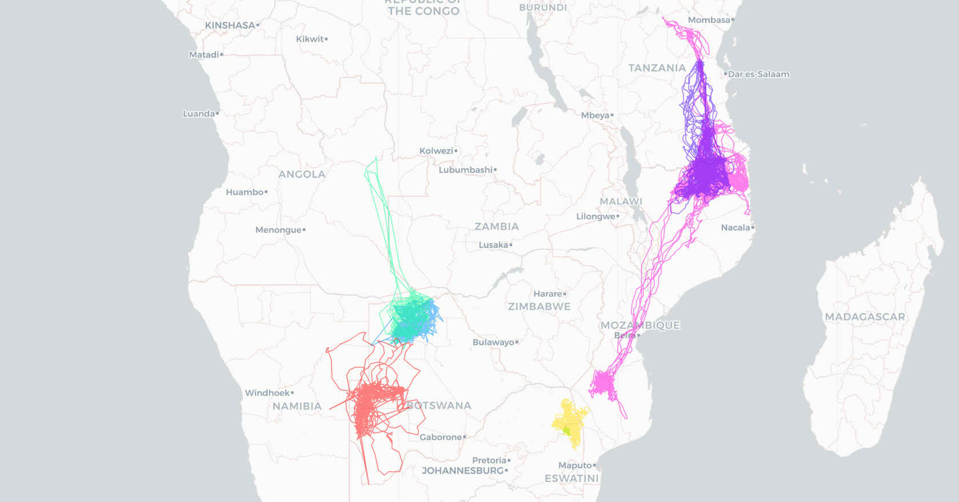
Figure 1: Satellite tracking (2021-2023) of bateleur across Southern Africa (data provided by Gareth Tate, Endangered Wildlife Trust in collaboration with the Max Planck Institute for Animal Behavior). Ages at tagging: Adults (light green/light blue), subadults (violet/pink), immatures (yellow/turquoise), and juvenile (red).

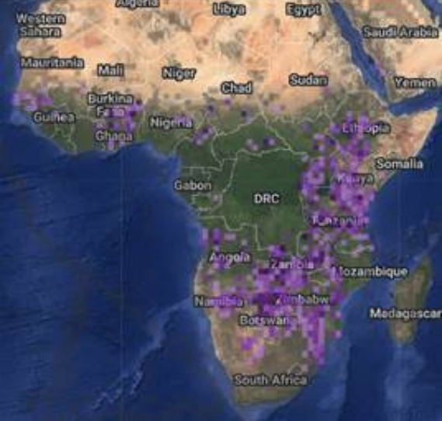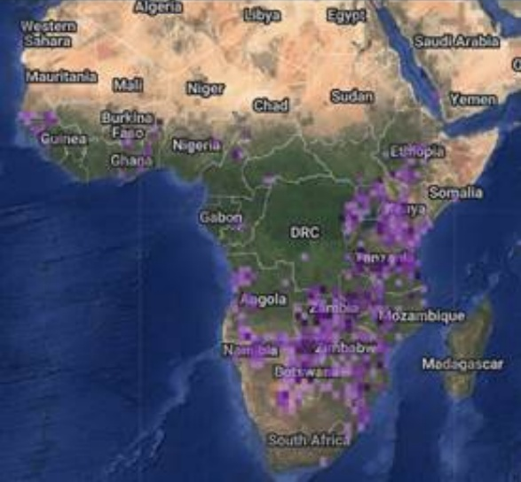
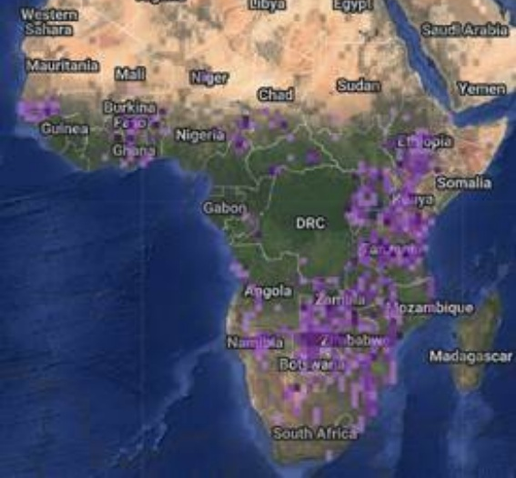
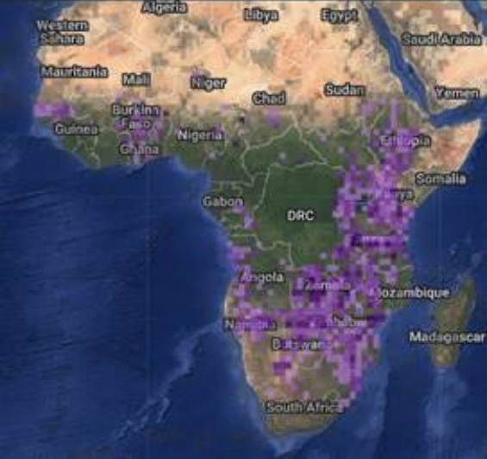
Figure 2: Observations of Terathopius ecaudatus from eBird split into four seasons: Mar-May (top left), Jun-Jul (top right), Aug-Nov (bottom left), Dec-Feb (bottom right)

Red-headed falcon (Falco chicquera)

Red-headed falcon (Falco chicquera), distributed in Asia and red-necked falcon (Falco ruficollis), distributed in Africa, are currently considered as two separate species by BirdLife International. However, several authorities treat them as a single species, red-necked falcon (Falco chicquera) with separate populations, one found in Asia and another in Africa. They consider three subspecies: Falco chicquera chicquera (Asia), Falco chicquera ruficollis (sub-Saharan Africa), and Falco chicquera horsbrughi (Southern Africa). AviList, developed with the aim of harmonising the global checklist of birds, treats it as a single species and BirdLife International is working towards alignment with AviList.

Falco chicquera was treated as a single species by Ferguson-Lees and Christie (2001), who described it as generally sedentary, but locally and regionally nomadic in response to seasonal rains and droughts. Bildstein (2006) classified the species as a “rains migrant”, i.e. a species that regularly migrates in response to seasonal rainfall patterns. A recent study showed that the species can shift its trophic niche from feeding on birds to feeding on bats, suggesting an ability to track and adapt to changing environmental conditions (Foysal and Panter 2024).

The Indian population is considered resident, although partial nomadism has been reported in some areas; however, these movements remain poorly studied (Naoroji 2006, del Hoyo et al. 2020, Bhatt 2023). To our knowledge, there are currently no satellite-tracking or marking studies providing information on home ranges or local movements during the breeding and non-breeding seasons (see also Bhatt 2023). No studies on the species are currently available on Movebank. Seasonal patterns of observations from eBird do not show any shift, except into Assam, where the species has rarely been observed (Fig. 3). Local experts describe the species as non-migratory but also acknowledge the lack of available movement data (Foysal, M. pers. comm.).

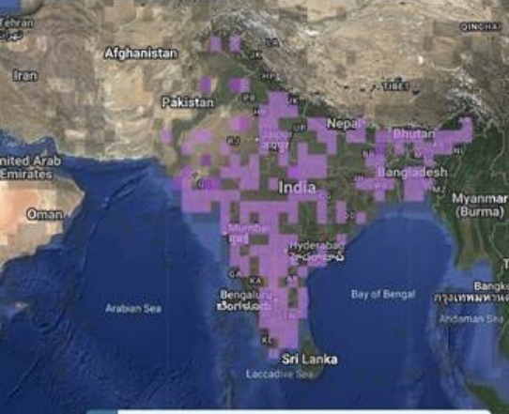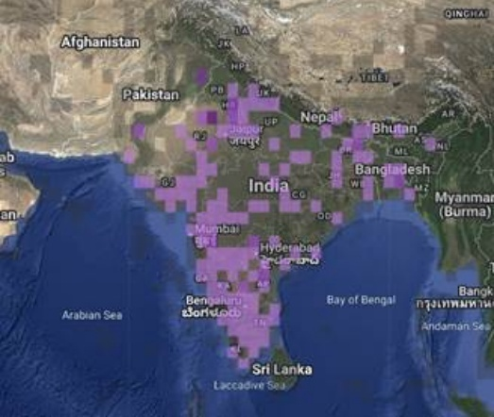
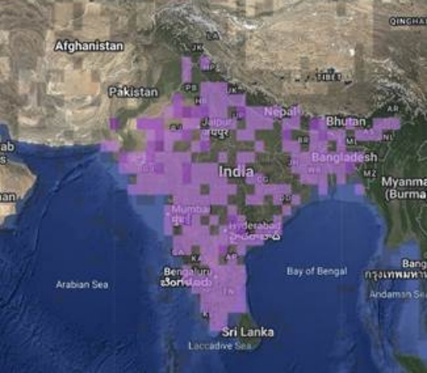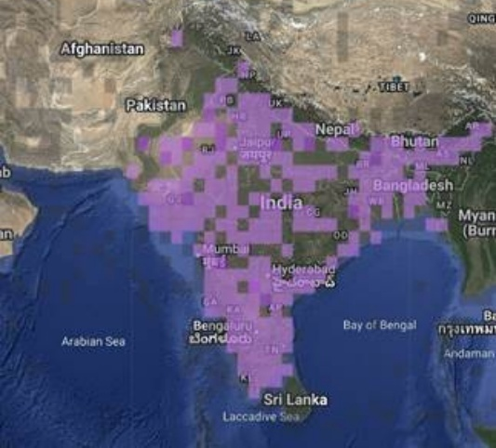
Figure 3: Observations of Falco chicquera chicquera from eBird split into four seasons: Mar-May (top left), Jun-Jul (top right), Aug-Nov (bottom left), Dec-Feb (bottom right)

The CMS Scientific Councillor for birds assessed Falco chicquera as meeting the CMS movement criteria, but with low confidence. Falco ruficollis was assessed as not meeting the criteria, with very high confidence. The TAG considered these assessments together with the other available information. Given the absence of tracking or marking evidence, the lack of a clear seasonal distributional shift and the uncertainty arising from the differing taxonomic treatment of the Asian and African populations, the TAG concluded that the available evidence was insufficient to demonstrate that a significant proportion of Falco chicquera, as currently defined by BirdLife International, cyclically and predictably crosses one or more national jurisdictional boundaries.

On the basis of the information currently available, the TAG does not propose the addition of red-headed falcon (Falco chicquera), as currently defined by BirdLife International, to Annex 1. The species may be reassessed if further movement data become available or following the alignment of BirdLife International’s taxonomy with AviList.

Bonelli’s eagle (Aquila fasciata)

At MOS2, Israel proposed that Bonelli’s eagle (Aquila fasciata) be considered for inclusion in Annex 1 on the basis of its movements and TAG requested further evidence, particularly on the movements of wild-hatched individuals. At the Ninth Meeting of the Technical Advisory Group to the Raptors MOU, Mr Hatzofe presented further evidence from a number of tracked individuals highlighting the regular long range largely directional seasonal movements of juveniles, representing approximately 10% of the population from Israel and Greece. The information was based on movements of 55 birds tagged in Israel as chicks and about 20 in Greece. He added that when eagles started to breed, they became more sedentary. The TAG considered the case presented convincing.

Below is additional evidence that Bonelli’s eagles exhibit migratory movements consistent with the CMS definition of “migratory species”.

While adult Bonelli’s eagles (typically aged three years or older) are highly territorial and sedentary, with strong site fidelity and territoriality (Bosch et al. 2010, Martínez-Miranzo et al. 2016, Morollón et al. 2022), juveniles are highly nomadic and show no territorial behaviour (Real and Mañosa 2001, Cadahía et al. 2010, Hernández-Matías et al. 2010). The nomadic movements begin at the age of 163 ± 17 days and last until the birds become territorial, at least two years later (Real et al. 1998, Minguez et al. 2001). In the Iberian Peninsula, average displacements was 356 ± 156 km from their natal sites (Hernández-Matías et al. 2010, Cadahía et al. 2010). However, recent GPS telemetry data have revealed exceptional long-distance movements, including movements from Spain to Morocco (Life Bonelli’s Project 2024; https://www.lifebonelli.org/index.php/en/) and from the Aegean islands to Central Europe (Fig. 4) and to East Africa (Life Bonelli EastMed 2024; https://www.lifebonelli.eu/en/, Fig. 5). The species exhibits wide variability in movement behaviour, from localised settlement to transcontinental movements. Raw dispersal trajectories (Fig. 6) of juvenile Bonelli’s eagles (N=55) from the three different biogeographic zones in Israel: Mediterranean (dark grey); Semi-desert (blue); Desert (yellow and orange) demonstrate that individuals from an arid natal area have a particular tendency to perform long-distance movements that fall under the CMS definition of migratory behaviour (for details, see Mayrose et al. 2026).

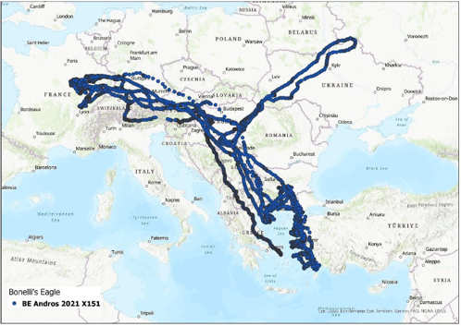
Figure 4: Movement of a A. fasciata from the Aegean island Andros

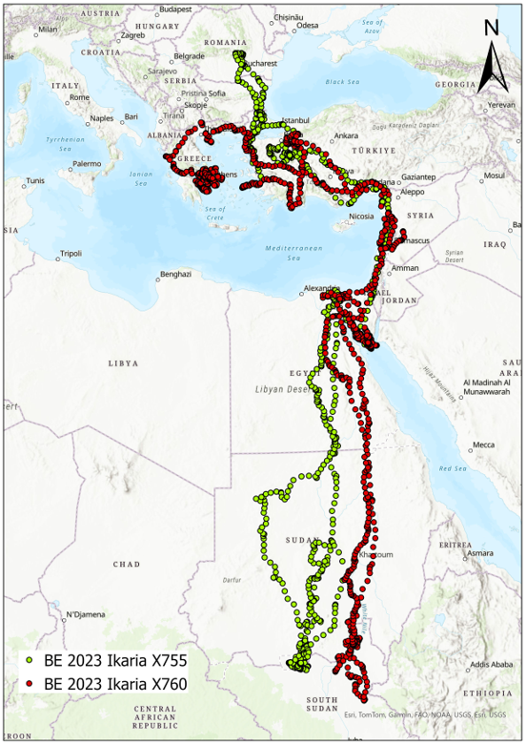
Figure 5: The movement of two A. fasciata from the Aegean island Ikaria (Life Bonelli EastMed project).

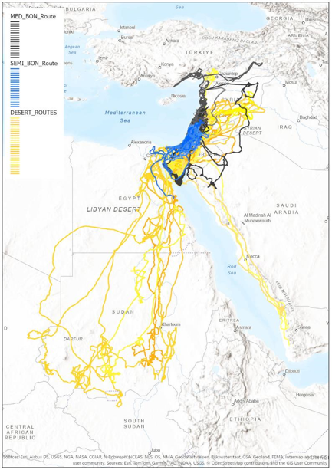
Figure 6: Trajectories of 55 juvenile A. fasciata from the three natal-habitat groups: Mediterranean (dark grey), Semi-desert (blue) and Desert (yellow and orange).

Although adults are predominantly sedentary, juveniles constitute a regular and ecologically distinct component of the population and remain mobile for an extended period before recruitment into the breeding population. The available tracking evidence indicates that this component includes individuals that undertake cyclical and predictable movements across international boundaries. On this basis, the TAG considers the mobile juvenile component to constitute a significant proportion of the geographically separate populations concerned for the purpose of applying the CMS definition.

Aquila fasciata has also been assessed by the CMS Scientific Councillor for birds who concluded that the species meets CMS migratory criteria with high confidence (Table 1).
The TAG concurs with the conclusion that Bonelli’s eagle meets the CMS definition of “migratory and proposes that the species added to Annex 1.

https://www.cms.int/en/document/taxonomy-and-nomenclature-0
Handbook of the Birds of the World and BirdLife International Illustrated Checklist of the Birds of the World. Volume 1: Non-passerines. Lynx Edicions, Barcelona.
http://datazone.birdlife.org/species/taxonomy
https://www.birdlife.org/wp-content/uploads/2021/10/BirdLife-European-Red-List-of-Birds-2021.pdf
Westrip, J.R.S., Burfield, I.J., Allen, D.J. and Numa, C. (2022). The Conservation Status of Breeding Raptors in the Mediterranean. IUCN, Málaga, Spain.
https://www.birdlife.org.za/red-data-book/
³ Based on Annex 1 as amended by the Third Meeting of Signatories in 2023 and effective on 7 July 2023. Globally threatened and Near Threatened species according to the latest IUCN Red List, (CR = Critically Endangered; EN = Endangered; VU = Vulnerable; NT = Near Threatened).
⁴ Species that are considered to have Unfavourable Conservation Status at a regional level within the area (defined in Annex 2) of the MOU. Effectively this comprises Annex 1 species which are Least Concern on the Global IUCN Red List, but are either: Species considered to have an Unfavourable Conservation Status at the regional level within the area of the MOU, as defined in Annex 2. This category comprises species listed in Annex 1 that are classified as Least Concern on the global IUCN Red List and to which one or more of the following apply: - Listed as threatened or Near Threatened (including SPEC listing in Europe or equivalent in other regions) on the European Red List of Birds (2021); or, - On the basis of BirdLife International data 2021, would meet criteria to be considered as Species of European Conservation Concern -SPEC1, SPEC2 or SPEC 3 (as in BirdLife International (2004) Birds in Europe: population estimates, trends and conservation status. Cambridge, UK: BirdLife International Conservation Series No.12); or - Have a declining global population trend according to the Birdlife International database 2022 - the species is classified as threatened or Near Threatened in a regional assessment or meets established criteria for designation as a species of regional conservation concern, including designation as a Species of European Conservation Concern or an equivalent designation in another region; - in the absence of a regional assessment, information collated from different parts of the region, supplemented where appropriate by expert opinion, is assessed by the Technical Advisory Group as demonstrating an Unfavourable Conservation Status across the region as a whole; or - the species has a declining global population trend according to the most recent assessment published by the IUCN Red List Authority for birds.
⁵ All other migratory species listed in Annex 1.
Note that BirdLife International uses a different definition of ‘migratory’ to CMS (see: https://datazone.birdlife.org/about-our-science/terms-and-definitions#migratory-status
https://www.avilist.org/checklist/v2025/

